INFORMATION ABOUT PET & HOME PORTRAITS

I print from high-quality photographs in acrylic or watercolor. Some subjects also lend themselves to collage and some look great in colored pencil. You may know exactly what media you would like or I can give suggestions for the best choice depending on your needs.

- Please allow 4 weeks. If I see a time issue because of my schedule, I will let you know. The farther in advance
- A good-faith 20% deposit is requested but not required earlier than 4 weeks ahead.
- Please indicate if you have a special wish for realistic or playful. Otherwise, I will pick the style I think works best with the subject.

The prices below are based on average needs. We can negotiate if you have special requirements (time constraints, more than one subject, unusual size.)

 | Acrylic | Watercolor | Colored pencil | Collage
8 x 10/11 |  | 200 | 150
9 x 12 | 200 | 250 | 175 | 225
11 x 14 | 230 | 300 | 200 | 250
12 x 16 | 275 |  | 250 | 275
16 x 20 | 300 |  |  | 300

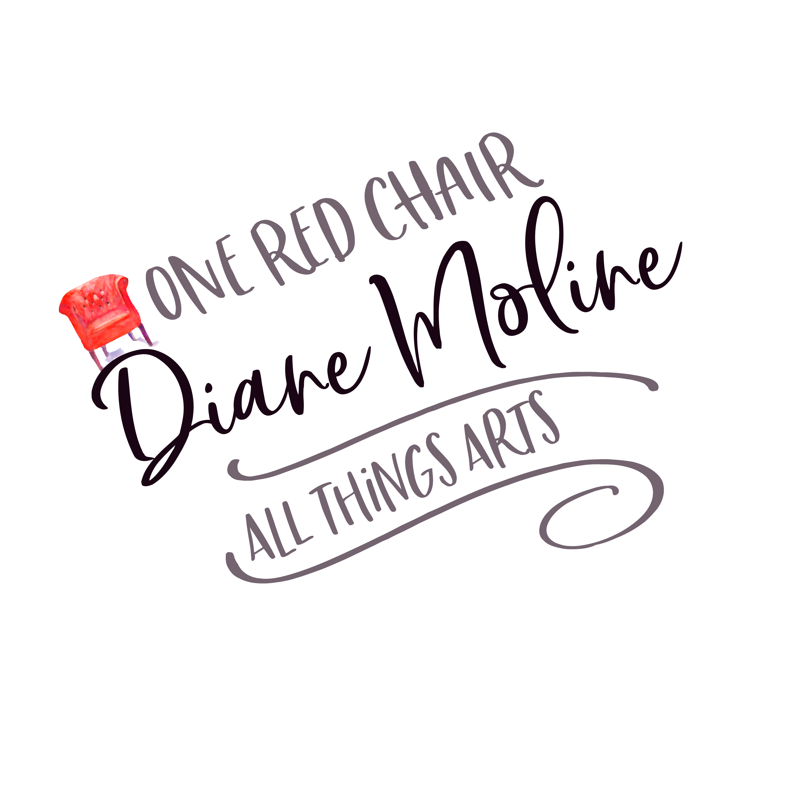
Diane Moline
One Red Chair Studio
Bonney Lake Washington 98391
dianemoline.com
email 1redchair@gmail.com
425 466 2759

